Government of Pakistan  Prime Minister Secretariat (Public)  Earthquake Reconstruction and Rehabilitation Authority (ERRA)  Islamabad | 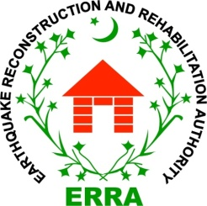

Date 26th Oct, 2016
Press Release

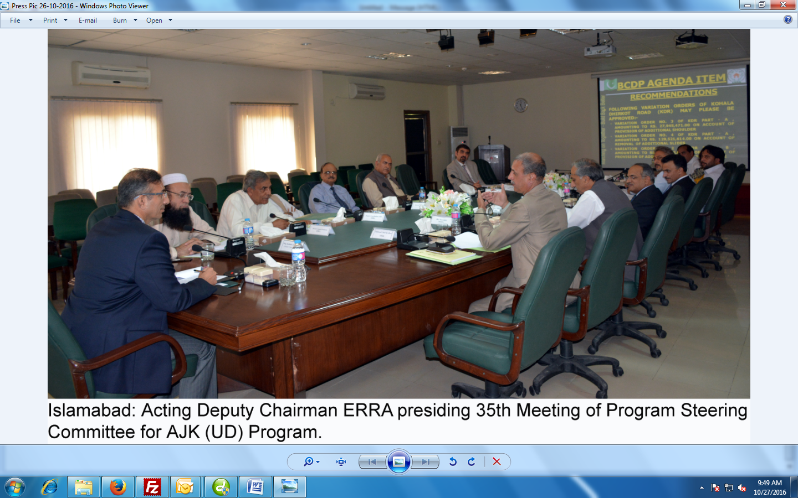

ERRA 35th Steering Committee Meeting Held at ERRA HQ’s

Islamabad: October, 26, 2016 (PR): Thirty fifth Program Steering Committee (PSC) meeting on urban development AJK was held at ERRA headquarters under the chairmanship of Acting Deputy Chairman Brig Abu Bakr Bajwa here today.

Director General State Earthquake Reconstruction Rehabilitation Authority (SERRA), Secretary Planning and Health Development Azad Kashmir, Commissioner of Muzaffarbad and Poonch NESPAK representative and the officials of ERRA attended the meeting along with Project Directors of the Muzaffarbad, Bagh and Rawalakot.

Welcoming the participants, the Acting Deputy Chairman ERRA stressed the need for timely completion of projects while catering for the needs of host government.

He also appreciated the role of host government for extending cooperation to ERRA facilitating land acquisition and resolve of Pakistan government in rebuilding the three cities of Muzaffarabad, Bagh and Rawalakot.

Today while most of the work stands completed the projects of urban development will end by December2016. The committee approved the nine changes to facilitate speedy construction as closing of projects is nearing.

END

